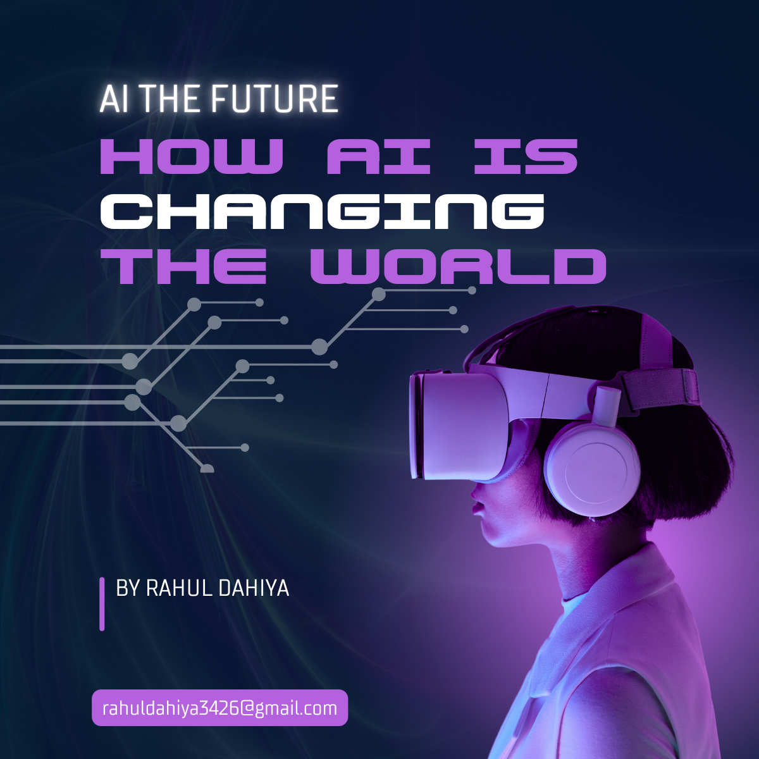

Artificial Intelligence (AI) is expected to bring about immense positive change, transforming various sectors and solving some of the world’s most pressing challenges. Here's how AI will help shape a better world in the coming years:

**1. Healthcare Advancements**

AI will revolutionize healthcare by enabling earlier and more accurate diagnoses. AI algorithms can analyze medical images, detect patterns, and help identify diseases like cancer, heart conditions, and neurological disorders much faster than traditional methods. AI-driven tools will also assist in **robotic surgeries**, providing precision that reduces risks and recovery times. Personalized medicine will be another key development, where AI analyzes individual patient data—like genetics, medical history, and lifestyle—to create tailored treatment plans. Additionally, AI will help predict outbreaks and monitor pandemics, enabling quicker responses to public health crises.

**2. Automation and Productivity**

In industries such as manufacturing, logistics, and agriculture, AI will drive efficiency by automating repetitive or dangerous tasks. Robotics powered by AI will take over **heavy labor**, reducing workplace injuries while speeding up production lines. In **agriculture**, AI will optimize crop yields through precision farming, using data analytics to determine the best times for planting, watering, and harvesting. AI-powered machinery will also make farming more sustainable by reducing waste and conserving resources like water and energy. Automation will also allow workers to focus on more creative and strategic tasks, enhancing productivity in the long term.

**3. Sustainable Solutions for Climate Change**

AI will play a crucial role in combating climate change and creating a more sustainable world. AI algorithms can predict natural disasters, track deforestation, and monitor changes in weather patterns, helping governments and organizations respond quickly to environmental threats. In energy management, AI can optimize energy grids to reduce waste, predict energy demand, and integrate renewable energy sources like solar and wind. AI-driven innovations will also help develop **eco-friendly technologies** and make **supply chains** more sustainable by reducing emissions and improving resource management.